Project Design Phase-II
Data Flow Diagram & User Stories
Date | 01 October 2026
Team ID | SWTID-2026-8116
Project Name | AI FitTrack API
Maximum Marks | 4 Marks

Data Flow Diagrams:
A Data Flow Diagram (DFD) is a visual representation of the information flows within a system. It shows how data enters and leaves the system, what changes the information, and where data is stored. Level 0 shows AI FitTrack API as one process; Level 1 breaks it into five processes.
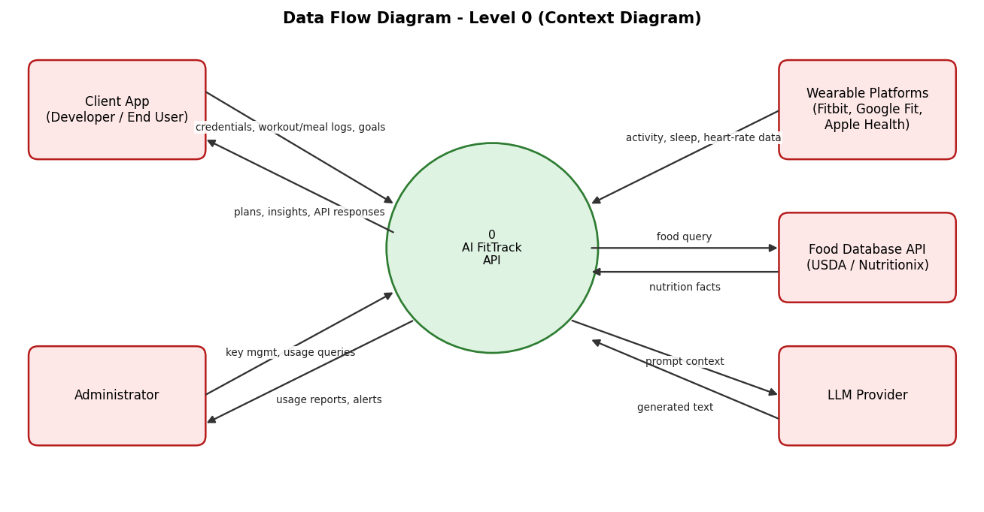
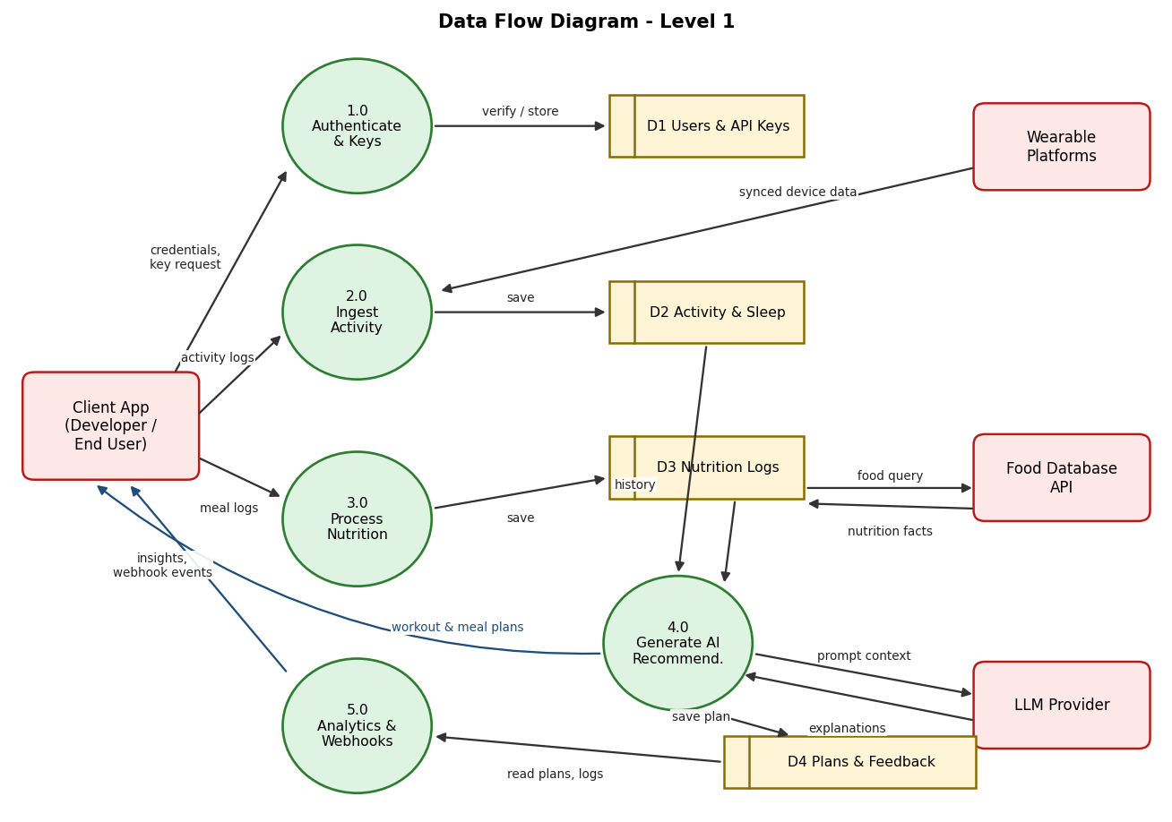
User Stories
User stories for the product, grouped by user type and epic.
User Type | Functional Requirement (Epic) | User Story Number | User Story / Task | Acceptance criteria | Priority | Release
Developer (API Consumer) | Registration | USN-1 | As a developer, I can register on the developer portal by entering my email, password, and confirming my password. | Account is created and I can open the portal dashboard. | High | Sprint-1
 |  | USN-2 | As a developer, I will receive a verification email after registering. | I receive the email and clicking the link activates my account. | High | Sprint-1
 | Authentication | USN-3 | As a developer, I can log in with email and password and receive a JWT access token. | Valid credentials return a token with expiry; invalid credentials return HTTP 401. | High | Sprint-1
 |  | USN-4 | As a developer, I can generate, rotate and revoke API keys for my application. | A new key is shown once; a revoked key is rejected within 1 minute. | High | Sprint-1
End User (via client app) | User Profile | USN-5 | As an end user, I can create my fitness profile (age, height, weight, experience level). | Profile is saved and returned by GET /profile. | High | Sprint-1
 | Workout Logging | USN-6 | As an end user, I can log a workout with exercises, sets, reps, weight and duration. | POST /workouts returns 201 and the entry appears in my history. | High | Sprint-1
 |  | USN-7 | As an end user, I can view my workout history filtered by date range. | Results are paginated and match the selected dates. | High | Sprint-1
Developer (API Consumer) | Developer Experience | USN-8 | As a developer, I can read interactive OpenAPI docs and see rate-limit headers on every response. | Swagger UI lists all endpoints; exceeding the limit returns HTTP 429. | Medium | Sprint-1
End User (via client app) | Nutrition Tracking | USN-9 | As an end user, I can log a meal by searching a food database. | Search returns matches in under 2 s; selected food is saved with calories and macros. | High | Sprint-2
 |  | USN-10 | As an end user, I can see a daily nutrition summary (calories, protein, carbs, fat). | Totals equal the sum of the day's logged meals. | High | Sprint-2
 | Wearable Integration | USN-11 | As an end user, I can connect Fitbit or Google Fit through OAuth and have my activity synced. | After consent, steps and workouts appear in my data within 15 minutes. | High | Sprint-2
 |  | USN-12 | As an end user, I can import an Apple Health export file. | Supported records are parsed and unsupported ones are reported, not dropped silently. | Medium | Sprint-2
 |  | USN-13 | As an end user, my sleep and heart-rate data is stored with my activity data. | Sleep duration and resting heart rate are retrievable by date. | Medium | Sprint-2
 | Goals | USN-14 | As an end user, I can set goals (weight, strength, endurance). | Goal is saved with a target date and shows progress percentage. | High | Sprint-2
 | AI Recommendations | USN-15 | As an end user, I can request a personalised weekly workout plan. | Plan matches my goal, level and recent history and is returned in under 5 s. | High | Sprint-3
 |  | USN-16 | As an end user, I can get AI meal suggestions that fit my daily macro targets. | Suggested meals total within 10% of my targets. | High | Sprint-3
 |  | USN-17 | As an end user, my plan adjusts automatically when I skip or complete workouts. | Next week's plan changes load or volume based on adherence. | Medium | Sprint-3
 | Progress Analytics | USN-18 | As an end user, I can view progress insights and trends over time. | Weekly and monthly trends for volume, weight and calories are returned. | Medium | Sprint-3
Developer (API Consumer) | Webhooks | USN-19 | As a developer, I can register a webhook to be notified of user milestones. | A signed POST is delivered within 30 s and retried on failure. | Medium | Sprint-4
End User (via client app) | Form Feedback | USN-20 | As an end user, I can submit pose keypoints for an exercise and receive form feedback. | Response lists detected form issues for squat and push-up. | Low | Sprint-4
Administrator | Admin Dashboard | USN-21 | As an administrator, I can view API usage, manage developer accounts and suspend keys. | Usage charts load for any date range; a suspended key is rejected immediately. | Medium | Sprint-4
End User (via client app) | Data Privacy | USN-22 | As an end user, I can export or delete all of my data. | Export is delivered as JSON within 24 h; deletion removes personal data within 30 days. | High | Sprint-4
Support Engineer | Monitoring | USN-23 | As a support engineer, I can search audit logs and receive alerts on error spikes. | Logs are searchable by key and user; an alert fires when 5xx rate exceeds 2%. | Medium | Sprint-4

